Directions: Please read through the whole test and follow the instructions of each section. All questions only have one correct answer; please choose the best answer. All answers should go on the scan sheet..
___1) This chart describes an experiment using a sample of water and three solids made of different substances. Three different solids are dropped into a wide beaker of water. Which property of water is being tested?
Solid 1- sinks halfway down the water and remains suspended.
Solid 2 - sinks to the bottom.
Solid 3 - floats to the top of the water.

  - Buoyancy/density
  - polarity
  - cohesion
  - solubility

____2) Explain how can the atmosphere be considered part of the hydrosphere?

  - It blocks ultraviolet rays from the sun
  - It contains the oxygen necessary for life on Earth
  - It traps pollutants that would otherwise harm the earth

  - It is a part of the water cycle.

____3) The majority of freshwater on the Earth is located where?
  - Pacific ocean
  - rivers
  - polar ice caps
  - Clouds
Substance | Specific Heat (J/kg•°C)
Lead | 128
Iron | 448
Glass | 837
Ice (water) | 2090

____4) This table shows the specific heat of four substances.
If each substance is exposed to the same amount of energy for
one minute, which substance will get the hottest?

  - iron
  - ice
  - Lead
  - glass

_____5) Water has many special properties such as adhesion, cohesion, surface tension, and being a universal solvent because the water molecule is polar. This means that the

  - the atoms are found mostly in the polar regions of the world
  - molecule has a positive charge on one side and a negative charge on the other due to unequal distribution of electron charge
  - molecule is connected in a straight line like a pole giving it a uniform electrical charge
.
  - Molecules are neutral.

_____6) A water molecule is made up of:

  - two hydrogen atoms bonded together
  - two oxygen atoms bonded to a hydrogen atom.

  - Two hydrogen atoms bonded to an oxygen atom
  - two oxygen atoms bonded together

_____7) . Approximately what percentage of Earth’s water is salt water?

  - 97 percent
  - 71 percent
  - 30 percent
  - 3 percent

_____8) Which statement best explains the reason some insects can walk across the surface of a lake?

  - Water is a polar molecule, and its high adhesiveness provides high surface tension.
  - Water is a non polar molecule, and its adhesiveness causes good capillary action
  - Water is a non polar molecule, and its cohesiveness causes good capillary action.
  - Water is a polar molecule, and its cohesiveness causes high surface tension.

_____9) . The diagram shows several underground layers and several wells (see below).
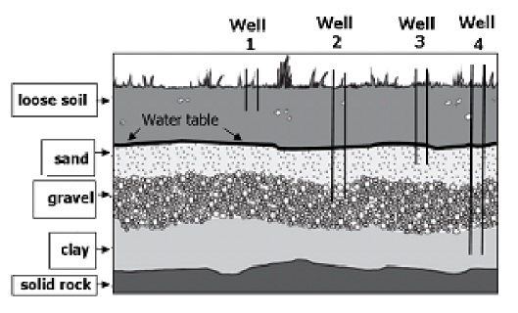
If the area experiences a severe drought, what is the most logical conclusion?
- The water table will rise
- The sand layer will expand
- Wells 1 and 3 will go dry.
- The saturated zone will be deeper.
.

______10) Most water vapor in the atmosphere comes from

- The burning from fossil fuels.
- Transpiration from plants.
- Evaporation from oceans.
- Evaporation from soil.

______11) Which explains where most of Earth’s freshwater is found?

- Water is stored in depressions on land as surface water.

- Water is stored as ice and snow in the Arctic Circle and Antarctica
- Freshwater infiltrates the soil during a rainstorm

- Water evaporates into the atmosphere from surface water.

______12) Which best describes the characteristics of a river basin?

- The land formed when rivers create estuaries and marshes
- the land drained by a river and its tributaries
- The land formed as a result of a river flooding
- The land at the mouth of a river where water flows into the ocean

______13) Living in Wake County, your ecological address is the river basin you live in .What is your ecological address?
A. Roanoke

B. Neuse
C. Tar- Palmica
D. Cape Fear

______14) River basins are made up of smaller_____________________ that drain into smaller ____________like streams and creeks or even smaller rivers. For example, the Flat and Eno Rivers, Crabtree, Swift, Contenna, and Walnut creeks are all smaller creeks found in the Neuse River Basin

- River basins, tributaries
- Watersheds, Tributaries
- Watersheds, River basins
- Tributaries, watersheds

______15) Which combination of processes from the water cycle is most likely to cause flooding?

- Low runoff, high infiltration, high condensation
- High runoff, low infiltration, high precipitation
- Low runoff, low evaporation, high transpiration
- High runoff, low evaporation, high precipitation

_____16) Which process is responsible for changing liquid water into water vapor (gas)?

- Evaporation
- Photosynthesis
- Precipitation
- Condensation

Use the water cycle diagram for #17
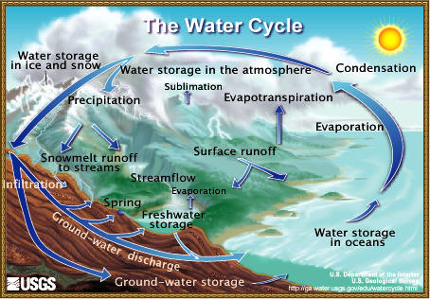

____17) The water cycle is the continuous movement of water between the earth’s surface and the atmosphere. The following processes are important to the water cycle. Where does the energy come from the drives the water cycle?
- Evaporation- change of a liquid to a gas
- Condensation- change of gas to a liquid
- Precipitation- the process of depositing water in liquid or solid form.
- Mechanical
- Chemical
- Wind
- Solar

_____18) Over 6 billion people on Earth use water every day, yet Earth’s water supply remains relatively constant. This is because ______________________________.

- Global warming melts ice to replace water that is used.
- Water is constantly being recycled through the water cycle
- Water exist in three phases on earth
- The sea level is rising

_____19). In early spring in the mountains as snow melts, water travels down the mountain and seeps into the soil and pores of the rocks. Water contained in the soil and the pores of the rock is called:

- Precipitation
- Ground water
- Runoff
- Water vapor

_____20) Which best describes the hydrosphere?

- All of its located above ground
- It is formed by climate change

- Most of it contains salt
- It is made of only freshwater

____21) Which of the following would best explain how minerals get into stream water?

- Rainwater that is high in minerals falls from the atmosphere into the stream
- Rainwater dissolves minerals out of the rocks and soil during runoff after heavy rain
- When water evaporates from the ocean, it takes minerals with it and redeposits them in rainwater into the stream
- The stream water absorbs minerals from the plants growing nearby.

____22) Plants and animals require water to survive. Although many plants and animals have lived throughout time, the water in our environment has not been used up. Explain why?

- Water continually flows from the center of the earth
- Organisms combine hydrogen and oxygen to make their own water
- Organisms return the water back to the environment after they use it
- Vast quantities of water are created in the clouds by lightening.
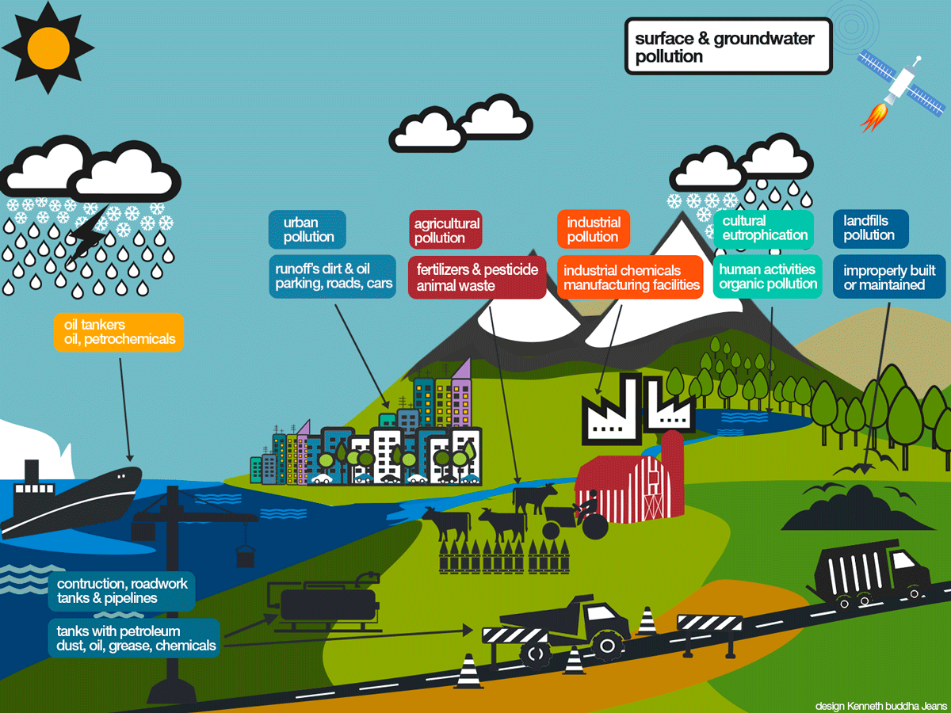

(Use diagram for #23)
_____23) Local environmental scientists have collected evidence of the presence of pesticides in the river. Pesticides are used on crops to prevent destruction of the crops by insects. According to the diagram, how might the pesticide reached the river?

- Precipitation
- Condensation
- Transpiration
- Surface runoff

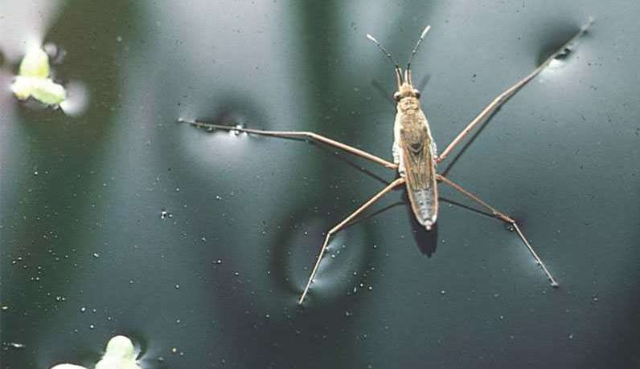

____24) Which property of water describes why a water strider appears to walk on water.

- Surface Tension
- Specific Heat
- Adhesion
- Cohesion

____25) Why is water from an aquifer more likely to be cleaner than water from other sources?

- Because pollutants are filtered by rock and soil as water infiltrates deep within the earth
- Because it forms where fresh and salt water meet
- Because it receives water directly from precipitation
- Because it rises to the surface near the ocean.

____26) Which best describes the characteristics of a river basin?

- All the land formed as a result of a river flooding
- The land at the mouth of the river where water flows into the ocean
- All the land drained by a river and its tributaries
- The land formed when rivers create estuaries and marshes

____27) A _____________________ is a natural filter of polluted water. It also acts as a sponge and slows down fast moving water. Swamps, bogs, and marshes are examples of these ecosystems. They are dominated by hydric soil and plants.

- Aquifer
- Tributary
- Aquitard
- Wetland

1 | Ocean to river to lake to atmosphere
2 | Aquifer to icecap to ocean to atmosphere
3 | Atmosphere to watershed to river to ocean
4 | Atmosphere to ocean to atmosphere to ocean

_____ 28) The water cycle has no beginning or end, but is has an order. Which of the following are the MOST likely ways that water would move through the water cycle?
- 4 and 1
- 3 and 4
- 1 and 2
- 2 and 3

_____29) Which percentage represents the amount of Earth’s water that is found in oceans.

- 1%
- 97%
- 3%
- 71%

_____30) Which factor most likely affects how water drains into local watershed?

- Differences in elevation
- Condensation
- Evaporation
- Precipitation

_____31) Which characteristic on an estuary makes it a good nursery are for marine organisms?

- It has many areas to hide from predators
- It is located at the mouth of the river
- It has the ability to absorb water and prevent flooding.
- It has a mix of salt and fresh water.

