Freshwater Review
Substance | Specific Heat (J/kg•°C)
Lead | 128
Iron | 448
Glass | 837
Ice (water) | 2090

____1) This table shows the specific heat of four substances.
If each substance is exposed to the same amount of energy for
one minute, which substance will be the coolest?
(If a pot of water is on a stove)
  - Glass
  - Lead
  - Iron
  - ice

Matching:
Properties

2. Surface Tension ____ This describes how water molecules are attracted to each other. They bead together at the surface.
3. Capillary Action ____ This causes water to be attracted to other polar molecules
4. Adhesion ____ The attractive force between water molecules due to the polarity
5. Cohesion ____ Water can dissolve so many substances
6. Solubility ____ the ability of to stick to other substances
- Universal Solvent ____ Roots of a plant send water upward to the stem and leaves

_____ 8) Water has many special properties such as adhesion, cohesion, surface tension, and being a universal solvent because the water molecule is polar.
This means that the
  - Molecule is neutral.
  - molecule is connected in a straight line like a pole giving it a uniform electrical charge
  - the atoms are found mostly in the polar regions of the world.

_____9) Two hydrogen atoms and one oxygen atom represent what type of molecule?
_____10) What percentage of Earth is freshwater?
  - 30 percent
  - 3 percent
  - 71 percent
  - 97 percent

_____11) The diagram shows several underground layers and several wells (see below).
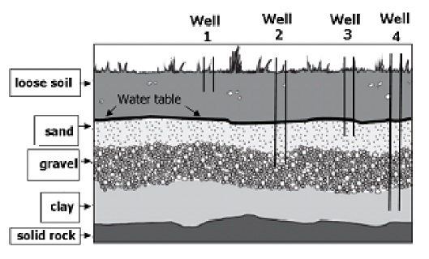
If the area experiences a severe drought, what is the most logical conclusion?
- The saturated zone will be deeper.
- Wells 1 and 3 will go dry.
- The water table will rise
- The sand layer will expand.

______12) Evaporation from oceans causes:
- Evaporation from soil.
- Water vapor in the atmosphere.
- Transpiration from plants.
- The burning of fossil fuels.

______13) Most of Earth’s freshwater is found in _____________ and icecaps?

- Oceans
- Mountains
- Glaciers

______ 14) Which best describes the characteristics of a river basin?

- the land drained by a river and its tributaries
- The land formed when rivers create estuaries and marshes
- The land at the mouth of a river where water flows into the ocean
- The land formed as a result of a river flooding

______15) Several __________________________ can drain into smaller __________________ like streams, creeks or even shorter rivers. They make up a river basin. For example, in the Neuse River Basin, the Flat and Eno Rivers, Crabtree, Swift, Contenna, and Walnut creek make up the river basin.
- Tributaries, watershed
- Watershed, river basin
- Watershed, tributaries
- River basins, tributaries

______16) Which combination of processes from the water cycle is most likely to cause flooding?
- Low runoff, low evaporation, high transpiration
- High runoff, low evaporation, high precipitation
- Low runoff, high infiltration, high condensation
- High runoff, low infiltration, high precipitation

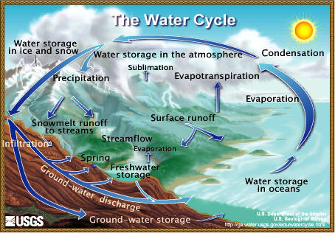
Use the water cycle diagram for #17
Match the terms associated with the water cycle.
17)________________Change of a liquid to a gas Condensation
18)________________Change of a gas to a liquid Solar
19)_________________Process of depositing water in liquid or solid Condensation
20)__________________Energy that drives the water cycle comes from this: Precipitation
T or F
21)______Water is called Nature’s recycling system.
22)_____The water basin that is located here is Wake County is the Tar-Pamlico
23)______A molecule that has a positive charge on one side and a negative charge on the other due to unequal distribution of electron charge is a property called polarity
24)______Water from an aquifer more likely to be cleaner than water from other sources because pollutants are filtered by rock and soil as water infiltrates deep within the earth.
25)______The Hydrosphere contains only freshwater
26)______ Rainwater dissolves minerals out of the rocks and soil during runoff after a heavy rain is how minerals get into streams.

______ 27) In early spring in the mountains as snow melts, water travels down the mountain and seeps into the soil and pores of the rocks. These areas are called ______________. The contained in the soil and the pores of the rock is called _________________.
- Runoff, Condensation
- Precipitation, runoff
- Aquifers, Groundwater

______________ 28) are natural filters of polluted water. It also acts as a sponge and _______ up/down fast moving water. Swamps, bogs, and marshes are examples of these ecosystems. They are dominated by hydric soil and plants.
- Wetlands, slows
- Aquitard, speeds
- Aquifer, slows
- Tributary, speeds

_______29) There are 17 river basins in N.C. Those that flow east or flow southeast end up dumping the water into the:
a) Gulf of Mexico b) Mississippi River
c) Atlantic Ocean d) Pacific Ocean

_______30).After 4 days of heavy rain in the spring, the river becomes cloudy and turbid with increase sediment. After several water quality tests, it is discovered that not only is the water turbid but it contains high levels of nitrates and phosphates. What else could be in the runoff?

- Oil and gasoline from leaky cars
- Detergent runoff from carwashes
- Fertilizer runoff from lawns and golf courses
- Exhaust

31) North Carolina has 17 watersheds or river basins. The majority of Wake County is in the ______________ _________________ basin. This is your ecological address.

32) A ________________ forms when a depression in the land fills with water over time from underground sources &/or precipitation.

33) Underground layer of rock or sediment that holds water is called a
______________________. Many people use this water for drinking by wells.

34) The top layer of the saturated zone is called the
__________ ___________.

a) permeable
b) water table
c) aquifer
d) Neuse River
e.) watershed
f.) Runoff

35) Groundwater moves easily through materials are called________________
36) Rain that cannot be absorbed into the ground collects on the surface, forming _____________ streams.

